Automated cocoa garden robot and real-time cocoa disease analysis with CNN
Supphakon Yimi¹, Jirapong Thawonkaew¹
Advisors: Thapanawat Chooklin¹, Kutsalin Thipmanosing¹

¹Princess Chulabhorn Science High School Nakhon Si Thammarat, 120 Village No.1, Sunanan Road, Bangchak Subistrict, Mueang Nakhon Si Thammarat District, Nakhon Si Thammarat 80000, Thailand
*E-mail: t.lookmee@pccnst.ac.th

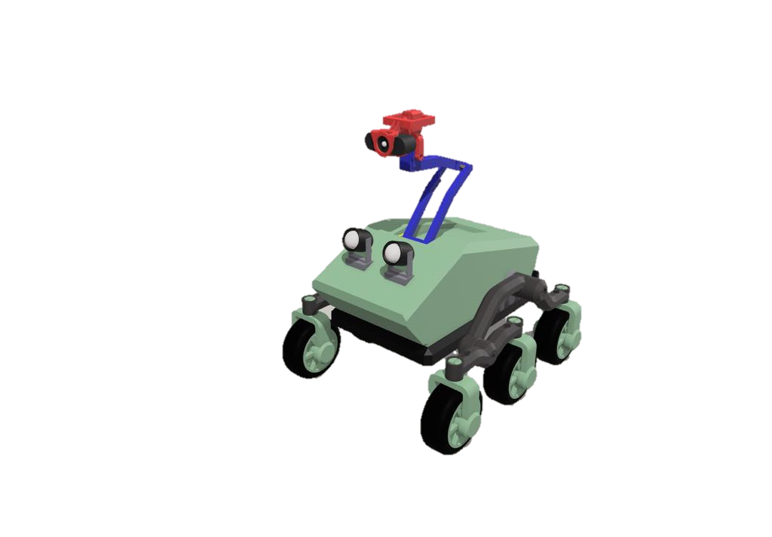

At present, agriculture is an important part of human life because it is the main food producer for people. Cocoa, as a future economic plant in Thailand, will play an important role in strengthening the economy of Thailand in the future. However, due to climate change, there is both the rainy season with a large amount of rainfall and the hot season that has to face a more severe drought than usual. More abundant rainfall has led to the creation of a large number of swamps on farms, which has caused the spread of cocoa diseases such as black pod disease, swollen shoot virus. As a result, farmers face obstacles in farming because of the spread of cocoa diseases. If not prevented or carefully cared for, these diseases could to other plants, and cause damage to agricultural products, leading to poor quality products, and massive losses of income for farmers. Thus, the creators developed an automatic cocoa garden care robot that uses Convolutional Neural Network to check for plant diseases. The robot captures images of cocoa trees with a camera and then sends them to a processing unit to analyse abnormalities of the cocoa tree. Farmers can be informed about the problems and prevent the spread effectively. The robot can move automatically along paths specified by the farmer and covers the entire farm. The developed robot will help farmers take care of their crops efficiently, resulting in high - quality agricultural products and saving both time and labor, as well a creating sustainable income for farmers.

Keywords: Climate Change, Cocoa Disease, Convolutional Neural Network, Automatic Robot

1. Introduction
At present, agriculture plays an important role in human life because it provides the main source of food producer people. Cocoa, the future cash crop of Thailand, will play a significant role in strengthening the future economy of Thailand’s. In 2023, 80% of cocoa production will be sold domestically and 20% will be exported to neighboring countries, which is expected to generate sustainable income in the future. However, climate change caused by abnormal weather patterns affects the environment in various ways, causing both the rainy season to have a large amount of rainfall, including the hot season that causes more severe droughts than usual. The increased rainfall has led to the formation of swamps in plantation, leading to the spread of cocoa plant diseases such as black pod rod and swollen shoot virus, causing farmers to encounter the obstacles. If not prevented or taken care of carefully, it may spread to other plants, resulting in damage to agricultural products, poor quality products, leading to a large loss of income for farmers. Therefore, the developer has developed an automatic cocoa plantation care robot and analyzed plant diseases in cocoa to let farmers know about them and prevent the spread of diseases effectively

2. Framework
This project is an automated cocoa garden robot in Mars rover’s model, named “ACOABOT”. It’s used to detect cocoa diseases automatically while moving around the garden using AI and videos from a webcam, installed on the robot. A gardener can inspect information, including the robot’s location, the number of infected plants, and the robot’s view through a web application.
The dataset of cocoa diseases used for the processing and analysis of AI is limited and coverless all types of disease, thus making the detection less accurate for classifying the type of disease, especially in low light conditions. However, the project aims to help gardeners defect cocoa disease as soon as possible so that they can eliminate infected cocoa yield. As a result, the robot can reduce the damage caused by disease out breaks and reduce gardener labor.

3. Finding and Discussion
1. Research cocoa in Nakhon Si Thammarat and related content on robot development, including AI detection programming, CNN-Object detection (YoloV8) algorithm, web application development, microcontrollers, sensors, and robot manufacture
2. Search cocoa disease dataset to train an AI model, for the COCOA DISEASE DETECTION Computer Vision Project by Roboflow
3. Train the AI model
4. Plan and design the workflow of the project
4.1 Plan and design workflow of the robot operation
4.2 Plan and design workflow of the robot manufacture
5. Assemble the robot
6. Develop a web application, that communicates with the robot’s components
7. Test the performance of the robot.
7.1 Test the performance of the robot operation
7.2 Test the performance of AI detection
8. Fix errors and complete the project

Materials
Hardware
Structure parts
- ABS, PLA, and PET-G
- 6 Tires
- Nuts and bolts
Electronic parts
- 6 DC motors with Encoders (12 Volt)
- 6 servo motors (movement)
- Raspberry Pi 4
- Arduino MEGA 2560
- 3 motor controllers
- 12 Volt 7200 mAh Battery
- 2 spotlights
- 4 servo motors (stabilizer)
- 1 Webcam
Software
- Visual studio code program
- Python
- YoloV8
- Flask HTML, CSS, JavaScript
- Sharp 3D
Figure 1 Diagram of robot’s system

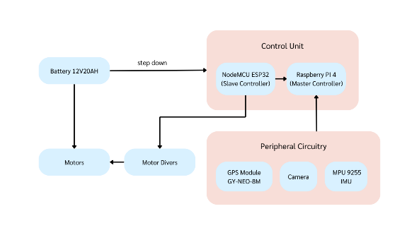

Figure 2 Diagram of autonomous movement system.

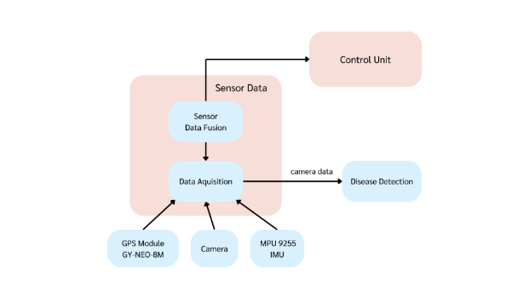

Figure 3 Confusion matrix

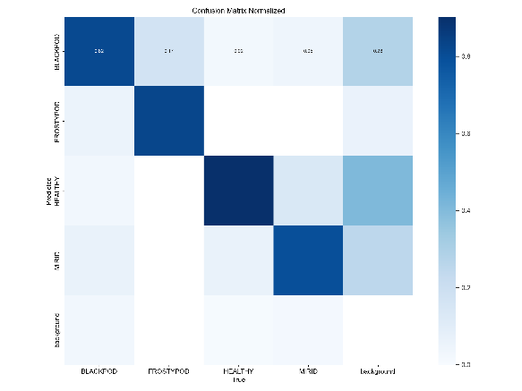

Figure 4 Use case of AI detection

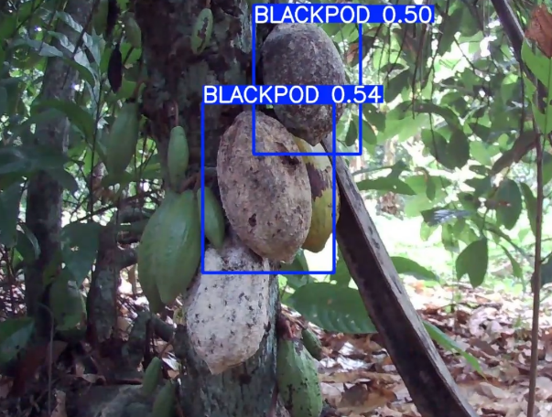

Figure 5 Acoabot

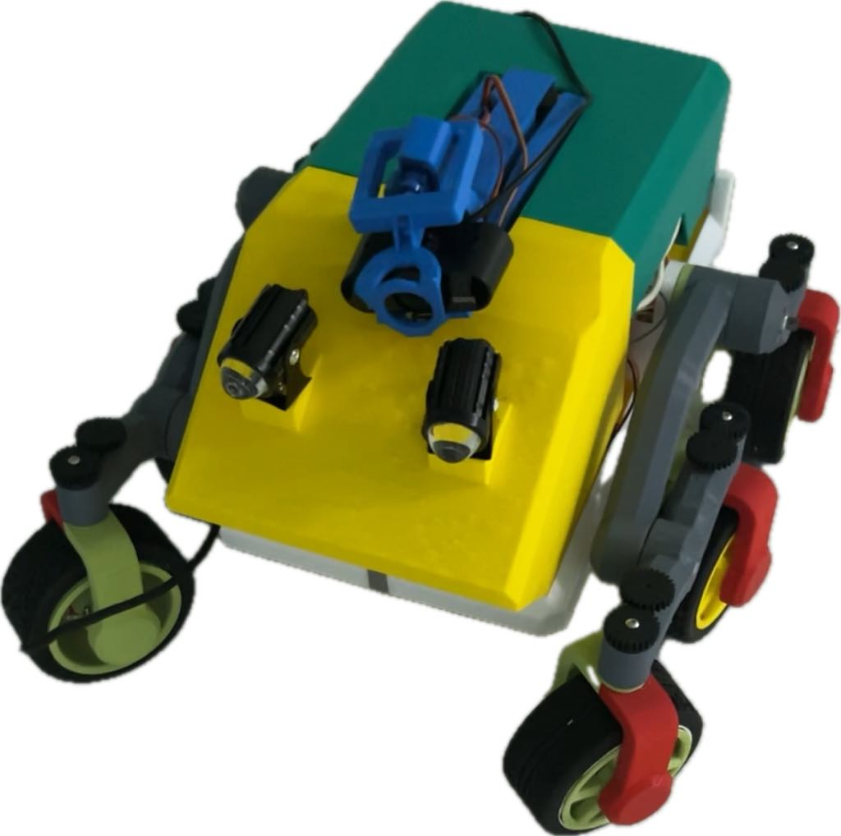

4. Conclusion
The main objective of developing the automatic cocoa plantation care robot and real – time detection of plant diseases in cocoa using CNN, is to help farmers reduce the damage caused by plant diseases to cocoa production. In addition, it also focuses on collecting important data for analysis and more systematic management of cocoa plantations. Through the development, it has been found that farmers can be aware of the status of plant diseases and take preventative or treatment measures quickly and efficiently. By working in real time, the robot can detect and report on the status of plant diseases and environment in the cocoa plantation. The data can be sent through a server, allowing farmers to access the information and various statuses of the robot on the cocoa farm, helping them adjust the management of the cocoa plantation according the environment and needs.

5. Acknowledgement
This project was successfully completed thanks to the kindness and support of Mr. Thapanawat Chooklinand, Ms. Kutsalin Thipmanosing, and particularly Princess Chulabhorn Science High School Nakhon Si Thammarat who kindly provided advice and suggestions on improving various aspects of the report book and contributed equipment until this research was successfully completed.

6. References
Davinder Singh, Naman Jain, Pranjali Jain, Pratik
Kayal, Sudhakar Kumawat, and Nipun Batra. 2020. PlantDoc: A Dataset for Visual Plant Disease Detection. In Proceedings of the 7th ACM IKDD CoDS and 25th COMAD (CoDS COMAD 2020). Association for Computing Machinery, New York, NY, USA, 249–253. https://doi.org/10.1145/3371158.3371196 [accessed 6 Jan, 2024]
Miss Nyarko, COCOA DISEASE DETECTION Dataset
.Roboflow , 2023. [Online]. Available: https://universe.roboflow.com/miss-nyarko-s2gtm/cocoa-disease-detection [accessed 6 Jan, 2024]
Deep Neural Networks and Kernel Density
Estimation for Detecting Human Activity Patterns from Geo-Tagged Images: A Case Study of Birdwatching on Flickr - Scientific Figure on ResearchGate. Available from: https://www.researchgate.net/figure/YOLO-network-architecture-adapted-from44_fig1_330484322 [accessed 6 Jan, 2024]
W. Lv et al., DETRs Beat YOLOs on Real-time Object Detection. 2023.
Jocher, G., Chaurasia, A., & Qiu, J. (2023).
Ultralytics YOLO [Computer software]. https://github.com/ultralytics/ultralytics [accessed 2 Jan, 2024]

